BULLETIN 2017-20 March 3, 2017
U.S. Department of Labor  Employment and Training  Administration  Office of Apprenticeship (OA)  Washington, D.C. 20210 | Distribution:  A-541 Headquarters  A-544 All Field Tech  A-547 SD+RD+SAA+; Lab.Com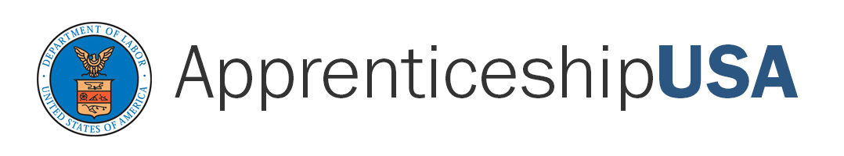 | Subject: New Apprenticeable Occupation: Coatings Inspector  Code: 200.1
Symbols: DPQSP/FJH |  | Action: Immediate
PURPOSE: To inform the staff of OA and the State Apprenticeship Agencies (SAA), Registered Apprenticeship program sponsors and other Registered Apprenticeship partners of the approval of two new apprenticeable occupation:

Coatings Inspector
O*NET-SOC Code: 51-9061.00
RAPIDS Code: 2051HY
Training Term: 3,032 - 3,632
Type of Training: Hybrid

BACKGROUND: The occupation, Coating Inspector Operator, submitted by Mr. Anton Ruesing, Director, Finishing Trades Institute, was approved by the OA Administrator on February 9, 2017. The Coatings Inspector examine and evaluate a variety of high-performance coatings applied to steel and concrete on complex structures, such as bridges and towers; waterfront structures, such as locks and dam, ship hulls, offshore platforms, bulkheads, and piers; metal and manufacturing facilities; chemical and processing facilities (e.g. food processing; pulp and paper mills; food and beverage plants; water and wastewater processing facilities); and conventional and nuclear power generation facilities.

ACTION: The OA staff should familiarize themselves with this bulletin and the attached Work Process Schedule and Related Instruction Outline, as a source for developing apprenticeship standards and/or providing technical assistance.

If you have any questions, please contact Felecia Hart, Team Leader, Division of Program Quality, Standards and Policy at (202) 693-3792.

NOTE: This bulletin is being sent via electronic mail.

Attachments

