BULLETIN 2017-18 March 3, 2017
U.S. Department of Labor  Employment and Training  Administration  Office of Apprenticeship (OA)  Washington, D.C. 20210 | Distribution:  A-541 Headquarters  A-544 All Field Tech  A-547 SD+RD+SAA+; Lab.Com  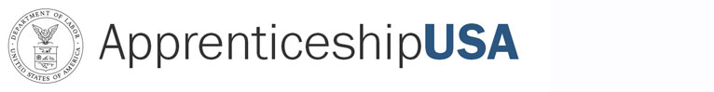 | Subject: New National Standards of Apprenticeship for Amazon  Code: 400.1
Symbols: DPSP/SHS |  | Action: Immediate
PURPOSE: To inform the staff of OA and the State Apprenticeship Agencies (SAA), Registered Apprenticeship program sponsors and other Registered Apprenticeship partners of the approval of new National Standards of Apprenticeship for Amazon.

BACKGROUND: These new National Standards of Apprenticeship submitted by
Ms. Ardine Williams, VP, AWS Global Talent Acquisition, were approved by the OA Administrator on January 6, 2017. The new National Standards of Apprenticeship for Amazon, for the occupation of Cloud Support Associate (Existing Title: Computer Support Specialist) will be serviced by the National Office.

If you have any questions, please contact Stephen Sage, Program Analyst at (202) 693-3221.

ACTION: This bulletin is being provided to OA staff for informational purposes only. The OA National Office will be responsible for maintenance and technical assistance regarding this program.

NOTE: This bulletin is being sent via electronic mail.

