BULLETIN 2017-11 January 26, 2017
U.S. Department of Labor  Employment and Training  Administration  Office of Apprenticeship (OA)  Washington, D.C. 20210 | Distribution:  A-541 Headquarters  A-544 All Field Tech  A-547 SD+RD+SAA+; Lab.Com  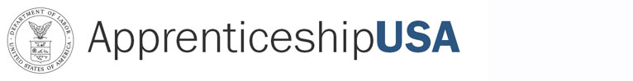 | Subject: New National Standards of Apprenticeship for SEIU/AFSCME National Center for Healthcare Apprenticeships - National Joint Apprenticeship Training Committee (NJATC).  Code: 400.1
Symbols: DPSP/SHS |  | Action: Immediate
PURPOSE: To inform the staff of OA and the State Apprenticeship Agencies (SAA), Registered Apprenticeship program sponsors and other Registered Apprenticeship partners of the approval of new National Standards of Apprenticeship for SEIU/AFSCME National Center for Healthcare Apprenticeships - NJATC.

BACKGROUND: These new National Standards of Apprenticeship submitted by
Mr. Daniel Bustillo, Director, Healthcare Career Advancement Program (H-CAP), were approved by the OA Administrator on October 21, 2016. The new National Standards of Apprenticeship for SEIU/AFSCME National Center for Healthcare Apprenticeships - NJATC, for the occupations of Hospital Coder and Community Health Worker will be serviced by the New Jersey Office of Apprenticeship.

If you have any questions, please contact. John Martinez, Apprenticeship Training Representative, at (732) 750-9191, or Stephen Sage, Program Analyst, at (202) 693-3321.

ACTION: This bulletin is being provided to OA staff for informational purposes only. The New Jersey Office of Apprenticeship, Region I, would be responsible for the maintenance and technical assistance of the program.

NOTE: This bulletin is being sent via electronic mail.

