BULLETIN 2017-10 January 26, 2017
U.S. Department of Labor  Employment and Training  Administration  Office of Apprenticeship (OA)  Washington, D.C. 20210 | Distribution:  A-541 Headquarters  A-544 All Field Tech  A-547 SD+RD+SAA+; Lab.Com  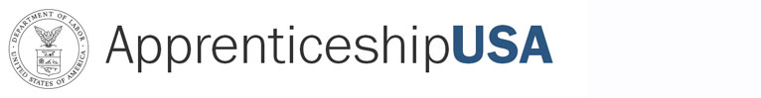 | Subject: New National Standards of Apprenticeship for Cummins, Inc.  Code: 400.1
Symbols: DPSP/SHS |  | Action: Immediate
PURPOSE: To inform the staff of OA and the State Apprenticeship Agencies (SAA), Registered Apprenticeship program sponsors and other Registered Apprenticeship partners of the approval of new National Standards of Apprenticeship for Cummins, Inc.

BACKGROUND: These new National Standards of Apprenticeship submitted by
South Carolina State Director Charles Vaughan, on behalf of Cummins, Inc., were approved by the OA Administrator on May 16, 2016. The new National Standards of Apprenticeship for Cummins, Inc., for the occupation of Diesel Engine Technician (Existing Title: Diesel Mechanic) will be serviced by the South Carolina Office of Apprenticeship.

If you have any questions, please contact Charles Vaughn, Apprenticeship State Director, at (803) 765-5548, or Stephen Sage, Program Analyst, at (202) 693-3221.

ACTION: This bulletin is being provided to OA staff for informational purposes only. The South Carolina Office of Apprenticeship, Region III, would be responsible for the maintenance and technical assistance of the program.

NOTE: This bulletin is being sent via electronic mail.

